**PYTHON PROJECT**

**Name: Kritika Singh**

**Enrollment no.:151311**

**Batch: B3 (BX)**

**TOPIC: SHOPPING PORTAL**

**Instructions for Execution of the Program:**

**1. First GUI**

The first windows that open up is an introduction window with my name and following credentials. To proceed to the main program you have to **click on PROCEED BUTTON->.**

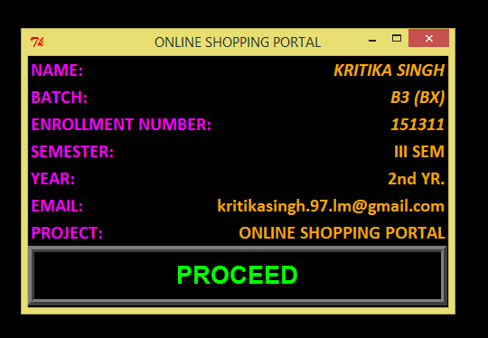

**2. Second GUI**

The second GUI that pops up on the window is the first screen of my Project. It mainly contains **2 BUTTON’s: a) Women Category b) Men Category.**

**Click on either Women category or Men Category to proceed.**

**Proceed->Women or Proceed->Men.**

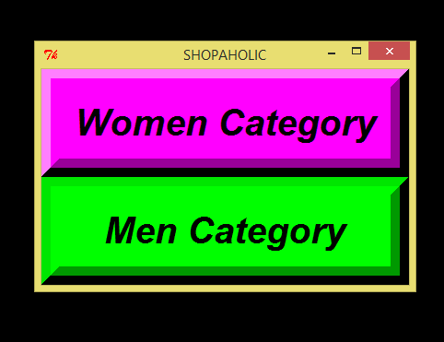

**3. Third GUI**

The third GUI contains of buttons as follows:

FOR WOMEN CATEGORY:

* **CLOTHES -> select BUTTON**
* **FOOTWEAR -> select BUTTON**
* **ACCESORIES -> select BUTTON**

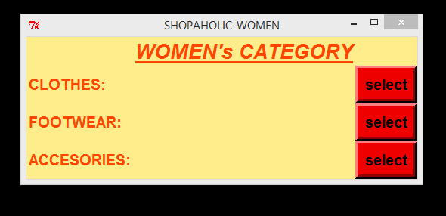

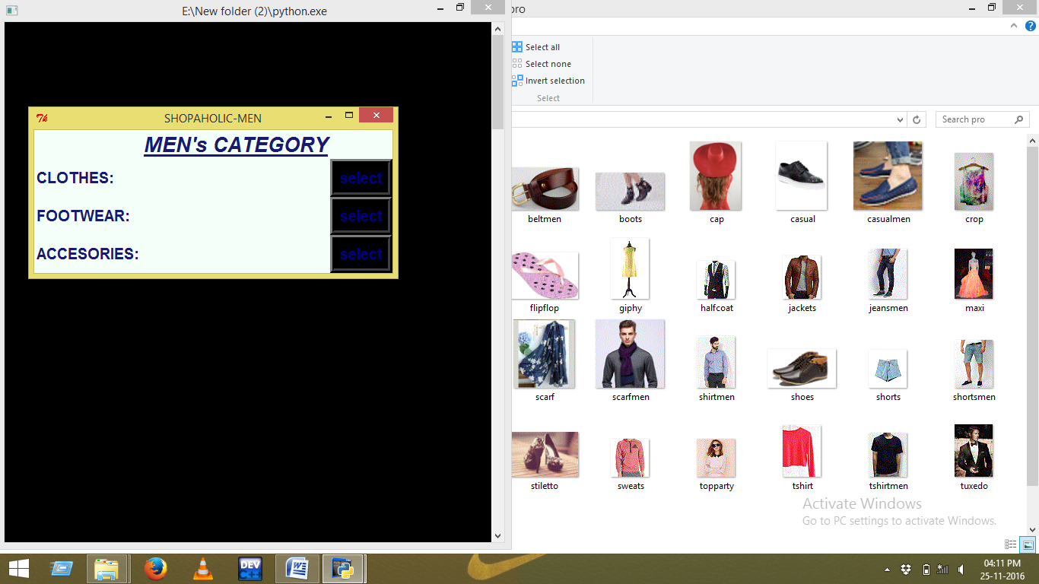

FOR MEN CATEGORY:

* **CLOTHES -> select BUTTON**
* **FOOTWEAR -> select BUTTON**
* **ACCESORIES -> select BUTTON**

**4. Fourth GUI:**

The fourth GUI contains various Buttons and CheckButtons.

In WOMEN CATEGORY:

**Following are the five buttons:**

**1. Dresses**

**2. Tops & Tees**

**3. Jeans & Skirts**

**4. Exit**

**5. Proceed to Checkout**

Click on first three buttons to check the items and clothes available that you can buy.

**Following are the nine checkbuttons:**

**CHECKBUTTONS**

**1. Dresses -> a) Mini Dresses b) Party Dresses c) Maxi Dresses**

**2. Tops & Tees -> a) T-shirts b) Crop Tops c) Party Tops**

**3. Jeans & Skirts-> a) Jeans b) Shorts c) Skirts**

**Dresses->Checkbuttons->Total amount for the Category**

To check the amount of the dresses you want to purchase click on the checkbuttons and the following prices of the clothes will be displayed below image of the clothes respectively.

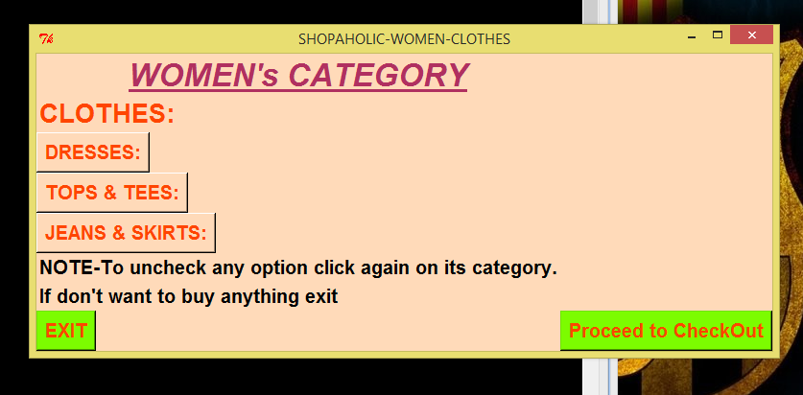 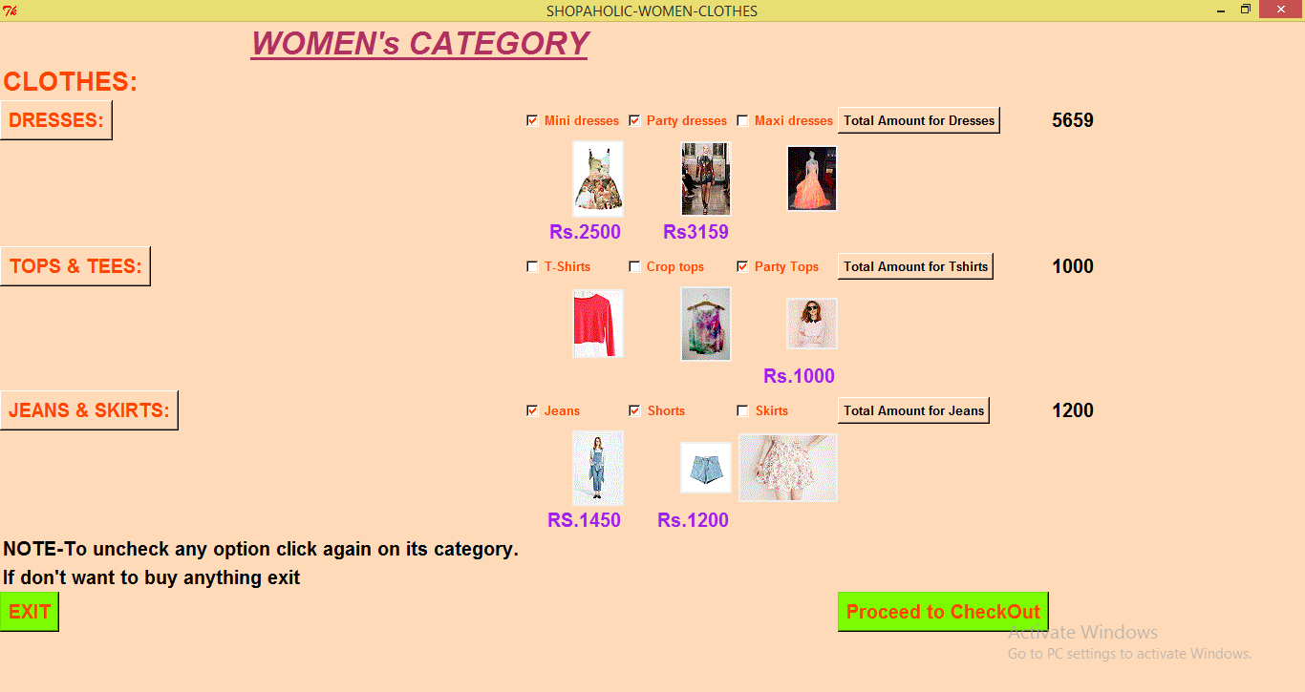

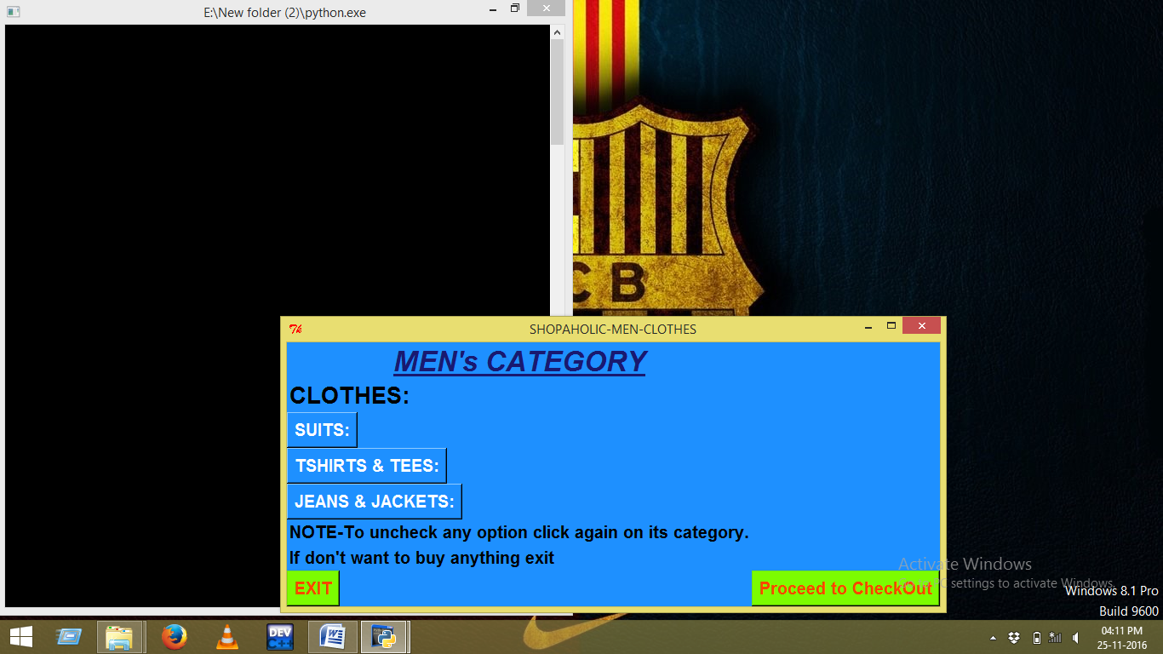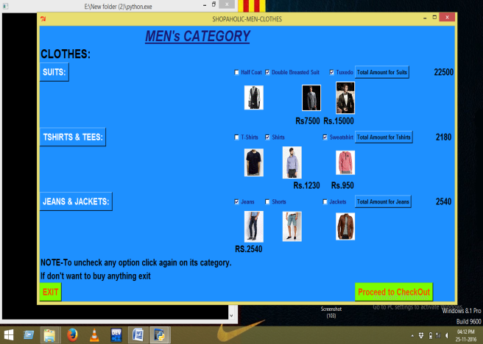

**-If you don’t want to purchase anything you can press EXIT BUTTON.**

**-Don’t click Proceed to Checkout until and unless you have selected any item.**

**5. Fifth GUI:**

The following fifth GUI opens up through **Proceed to Checkout Button.** When you press on proceed it will take you to a new GUI window which contains payment and Shipping details.

Once you fill all the respective details and click on **PAY BUTTON** payment is done.

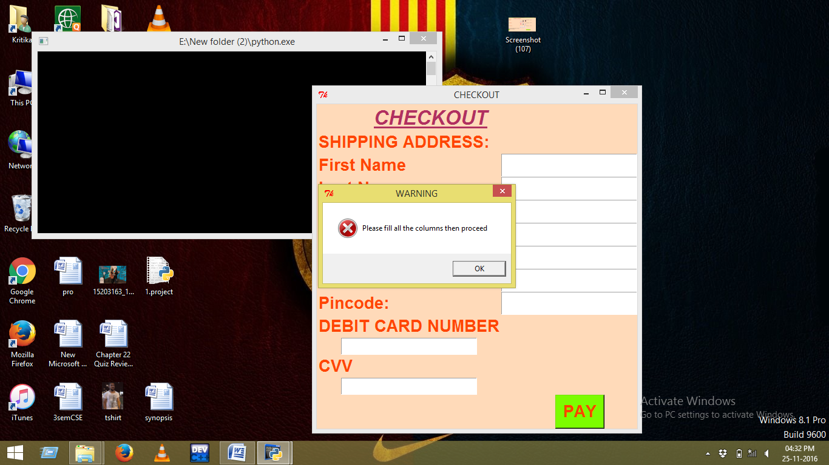 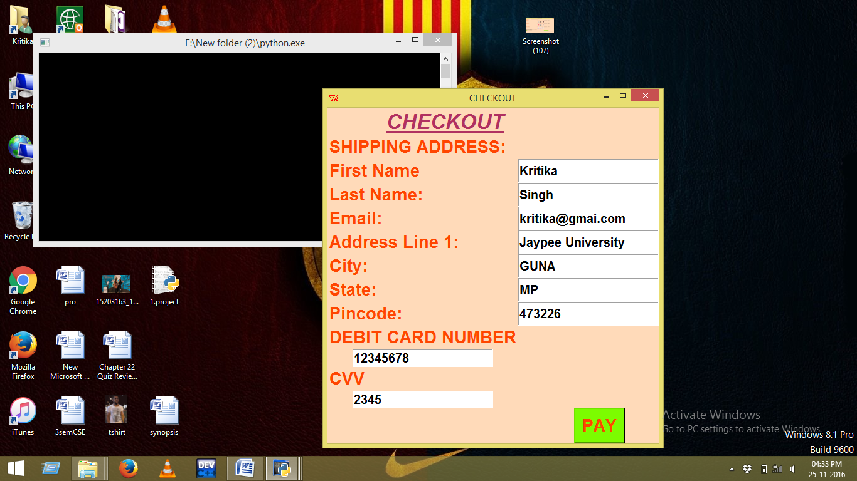

**6. Sixth & Seventh GUI:**

When you’ll click on **PAY BUTTON IN FIFTH GUI** payment will be done and by clicking on **PROCEED TO RECIEPT,** a new GUI will be pops up and your receipt of the shopping will be generated. 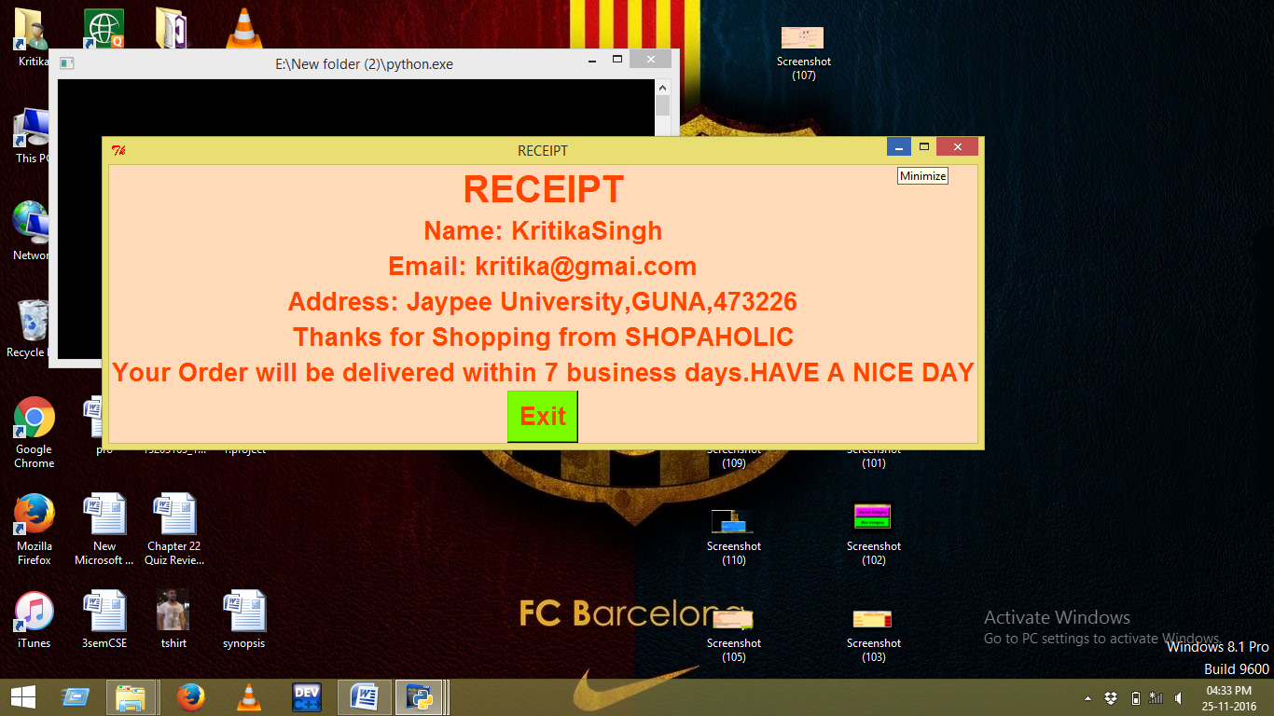

**\*NOTE-ALL THE INFORMATION IN SHIPPING GUI SHOULD BE FILLED TO PROCEED FURTHER OTHERWISE AN ERROR WILL BE SHOWN AS DISPLAYED ABOVE.**

**THE FOLLOWING ARE THE SCREENSHOTS OF BUTTONS OTHER THAN CLOTHES FROM BOTH MEN AND WOMEN CATEGORY:**

